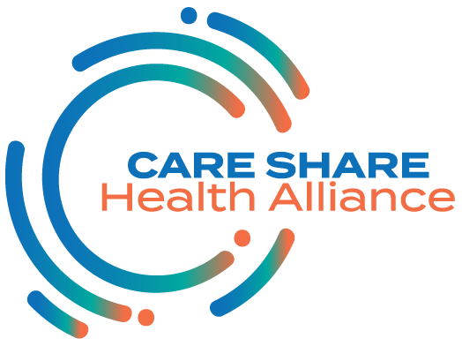

NC Get Covered Coalition Meeting
August 14, 2020
1:00-2:00 pm

1:00-1:05 Welcome, Meeting Purpose and Introductions
Megan Bolejack, Care Share Health Alliance

1:05-1:25 COVID-19 and Health Insurance Coverage Data
Anuj Gangopadhyaya, Urban Institute

1:25-1:40 Key Messages for SEPs
April Morgan, NC Community Health Center Association &
Mark Van Arnam, NC Navigator Consortium

1:40-1:55 Q&A

1:55-2:00 Wrap up and Next Steps

2:00 Adjourn

