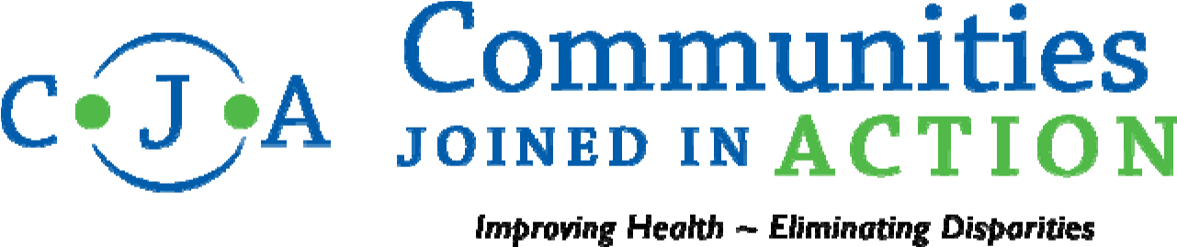

CONTRACTUAL POSITION OPENING

Regional Field Manager – SCALE 2.0

CJA is a private, non-profit membership organization of nearly 150 community health collaboratives – each of our members being committed to improving health, improving access, and eliminating disparities in their communities. Our mission is to mobilize and assist these community health collaboratives to assure better health for all people at less cost. CJA supports our members by facilitating the rapid dissemination of innovations across communities. We provide access to technical resources, peer-mentors from model communities, best practices, as well as host conferences and facilitate local networking opportunities. For more information, please visit: http://www.cjaonline.net/

CJA is a national partner with the 100 Million Healthier Lives, convened by the Institute for Healthcare Improvement (IHI) to build unprecedented collaboration of change agents across sectors that are pursuing an unprecedented result: 100 million people living healthier lives by 2020. The vision of 100 Million Healthier Lives is to fundamentally transform the way the world thinks and acts to improve health, wellbeing, and equity to get to breakthrough results.

SCALE was recently funded through the generous support of the Robert Wood Johnson Foundation and was created as a collaboration between the Institute for Healthcare Improvement, Communities Joined in Action, Community Solutions, and the Network for Regional Healthcare Improvement.

CJA is one of four national organizations that have come together to develop an approach for community transformation that will lead to a culture of change and sustainable improvement in health, wellbeing, and equity. The approach is called SCALE: Spreading Community Accelerators through Learning and Evaluation
(For more information, please visit: https://www.100mlives.org/initiatives/#scale2 )

CJA is recruiting for a part-time contractual position, Regional Field Manager, who will be responsible for working with a team to plan and implement a set of projects or initiatives within NC, SC and WV for the 100 Million Healthier Lives/SCALE portfolio. The Regional Field Manager will work closely with internal IHI teams, faculty, communities and other customers (individuals and organizations) to ensure delivery of the most effective and efficient programs and services to drive the improvement of health and health care outcomes worldwide.

Specific Position Responsibilities for the Regional Field Manager: This position will have two core pieces of work, Engagement and Logistics Coordination. The position will work with SCALE Communities that are located in NC, SC and WV. The position will report to the CJA Regional Team Leader located in NC. The following lists key position responsibilities:

Engagement:
- Manage and further develop 100 Million Healthier Lives’ relationships with communities, health systems, government and local funders within a defined geographic area, with an emphasis on advancing the SCALE Communities portfolio
- Work with the Regional Team Leader to develop new relationships within a defined geographic area to advance the broad goals of 100 Million Healthier Lives and/or to advance the work of a specific initiative
- Serve as the primary contact and spokesperson for 100 Million Healthier Lives to internal and external customers within the region
- Assist with coaching and follow-up support to SCALE communities and other members of 100 Million Healthier Lives
- Serve as a navigator to link communities to existing training, coaching and support resources
- Assist in linking individuals, programs, organizations and communities to 100 Million Healthier Lives by connecting them to the Community Health Accelerators Initiative (CHAI), Geographic Hubs, Topical Hubs and/or other initiatives that meet their needs and interests.
- Assist in developing relationships and securing funding and support from local government and foundations
- Work with the CJA Board of Directors to develop a membership engagement strategy that links CJA members with the SCALE opportunities. Coordinate CJA social media to promote/publicize initiatives among the membership, highlighting initiatives that align with SCALE.
Logistical Support:
- Provide logistical support to SCALE communities for their Regional Teams and/or States participating in States of Solution
- Provide logistical support to regional cohorts for the planning and implementation of Regional Community Health Improvement and Leadership Academies (CHILAS)
- Facilitate calls and/or meetings for Regions of Solution, States of Solution and/or other 100 Million Healthier Lives initiatives
- Proactively manage and adjust their portfolio of projects and responsibilities given workload changes, timelines, and organizational priorities
- Effectively delegate to and develop project coordinators within the assigned region.
- Prepare and edit communications for internal and external use

Position Knowledge, Skills, and Abilities:
- Excellent communication skills (both interpersonal and written)
- Strong project management skills, including being detail-focused and managing towards aggressive timelines
- Ability to think strategically – understand the big picture and proactively identify next steps, ability to optimize system and resources
- Ability to navigate difficult situations, including seeking input, escalation, and problem solving
- Ability to meet programmatic goals (financial, customer satisfaction, project results)
- Effective decision-making skills
- Ability to manage up and adapt style to meet project goals
- Ability to work independently and manage self towards goals, while being a genuine "team player"
- Willingness to undertake tasks at all levels when necessary
- Continuous improvement mindset
- Ability to balance multiple projects and teams and prioritize effectively
- Ability to work in a fast paced, sometimes ambiguous, environment
- Ability to learn and use new systems and technology

Position Qualifications:
- Bachelor's degree required
- Three to five years previous work experience in a professional environment required
- Prior project management experience preferred
- Proficiency with Microsoft Word, Excel, PowerPoint required
- Experience or knowledge of community health and social services preferred.

Compensation and Work Conditions:
CJA is seeking an Independent Contractor at an hourly rate of $22/hour for an initial contract period of six months, commencing November 17, 2017. It is projected that the contracted hours will not exceed 100 hours/month. Based upon successful completion of the scope of the work, contract is expected to renew for an additional 10 months

It is expected that the contractor will work virtually; therefore, the person will need secured access to appropriate computer technology for webinars and videoconferencing. There will be required travel to national meetings and all travel expenses will be arranged and paid by the 100Million Healthier Lives administrative office. Local/regional travel within NC, SC or WV is expected; mileage reimbursement will be provided under the contract.

Please send a cover letter and resume, NO LATER THAN October 20, 2017 to info@cja.org (preferably in MS Word format) or to the CJA Administrative Home Office:

Communities Joined In Action
c/o Georgia Health Policy Center
P.O. Box 3992
Atlanta, GA 30302

